Module Code | Module Name | Lecture Title | Lecturer



IT2050 –Computer Networks

Tutorial 05 - IP

1. Explain the TCP/IP model corresponds with the layers of OSI model. Use a diagram. Show the protocols running on each TCP/IP layers.



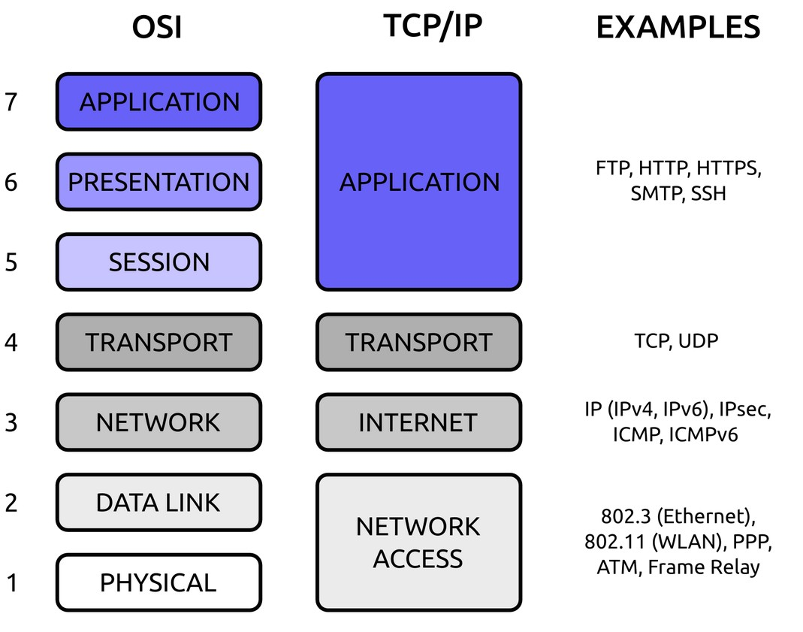

Module Code | Module Name | Lecture Title | Lecturer



##### An HLEN value of decimal 12 means,

1. What is the header length in bytes?

##### What is the length of ‘options’ field?

**Actual header length = HLEN X 4**

**=12 X4 = 48 bytes**

**length of ‘options’ field = 48 -20 = 28 bytes**

Module Code | Module Name | Lecture Title | Lecturer



* 1. What is the value of the total length field if the header is 28 Bytes and data field 400Bytes?

### Total length = Data size +Header size

**= 400+28**

### =428bytes

Module Code | Module Name | Lecture Title | Lecturer

* 1. 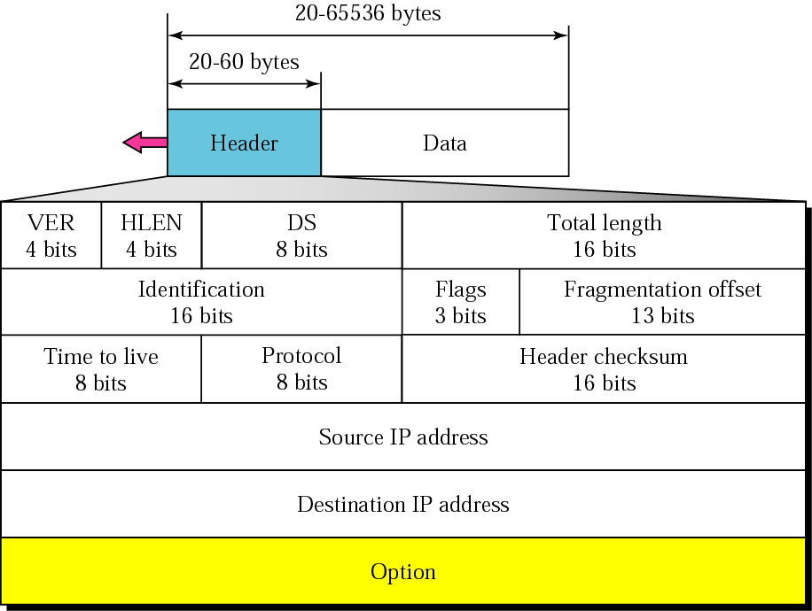What is the length of the data field when HLEN value 14 and total length value of 40000?



### Header size =14*4 = 56

**Data size =total length –Header size**

### = 40,000-56

**=39994 byte**

Module Code | Module Name | Lecture Title | Lecturer



* 1. **Which fields of the IP header change from router to router?**

**Time to live Header checksum**

Module Code | Module Name | Lecture Title | Lecturer



* 1. Calculate the HLEN value if the total length is 1200 Bytes, 1176 of which is data from the upper layers.

**Header length = total length – data length**

**= 1200-1176 = 24 bytes HLEN = 24/4 = 6**

Module Code | Module Name | Lecture Title | Lecturer



* + 1. Can the value of the header length be less than 20? When is it exactly 20?

### NO

Module Code | Module Name | Lecture Title | Lecturer



* + 1. An IP datagram has arrived with the following information in the header (in hexadecimal):

45 00 00 54 00 03 00 00 20 06 00 00 7C 4E 03 02 B4 0E 0F 02

1. Are there any options?
2. Is the packet fragmented?
3. What is the size of the data?
4. How many more routers can the packet travel to?
5. What is the identification number of the packet?
6. What is the type of Service?

Module Code | Module Name | Lecture Title | Lecturer



##### 45 00 00 54 00 03 00 00 20 06 00 00 7C 4E 03 02 B4 0E 0F 02

Version (4 bits ) = 4

HLEN (4 bits ) = 5 = 5*4 = 20bytes

DS (8 bits ) = 00 → Normal service

Total length= 0054 → hex(54) = 84 bytes Identification= 00 03 → 3

0000-> Flags & offset 000 0000000000000 → D = 0 , M =0 , offset = 0

* 1. > TTL = hex(20) → 32 routers 06 =Protocol → TCP

0000 =header checksum → No errors 7C4E0302 = source ip

B40E0402= destination ip

Module Code | Module Name | Lecture Title | Lecturer



* + 1. Are there any options? **No**
    2. Is the packet fragmented? **NO (M=0 and offset = 0 )**
    3. What is the size of the data? Data size = **84-20 =64bytes**

#### How many more routers can the packet travel to? **32 routers**

* + 1. What is the identification number of the packet? **3**

#### What is the type of Service? **Normal**

Module Code | Module Name | Lecture Title | Lecturer



##### A datagram is fragmented into three smaller datagrams / fragments. Which of the following is true?

1. The *do not fragment* bit is set to 1 for all three datagrams.



1. The *more fragment* bit is set to 0 for all three datagrams.

##### The identification field is the same for all three datagrams.

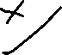

1. The offset field is the same for all three datagrams.



##### None of the above.



Module Code | Module Name | Lecture Title | Lecturer



* + 1. If the fragmentation offset has a value of 100 (in decimal), it means that .

1. The datagram has not been fragmented.

# The datagram is 100 Bytes in size.

1. The first byte of the datagram is byte 100.

# The first byte of the datagram is byte 800.

Module Code | Module Name | Lecture Title | Lecturer



## The checksum in the IP packet covers

1. Just the header

## Just the data

1. The header and the data

## Just the source and the destination addresses

Module Code | Module Name | Lecture Title | Lecturer